Yogesh Mainali

190345  Softwarica

Bank data management system

Contents

Table of figures 2

Introduction 3

Interface of the Program 3

Features 3

Adding Data 4

Updating Data 5

Deleting Data 6

Reset 7

Unit testing 8

Conclusion 9

Appendix 10

# Table of figures

Figure 1 Interface 3

Figure 2 Adding the data 4

Figure 3 Updating the database 5

Figure 4 Deleting the data 6

Figure 5 before 7

Figure 6 Resetting the interface 7

Figure 7 unit testing 8

# Introduction

The document illustrates the various features and different uses of the bank data management. The GUI is built using the Tkinter module of python whereas for storing data MySQL is used. The code has been written in python since it s a versatile language. This program helps to keep record of staff as well as customer that enter the bank or has a certain role in the bank premisses.

# Interface of the Program

Below is the interface of the program that has been made. It includes and illustrates on how the application looks its uses and the buttons for its usage

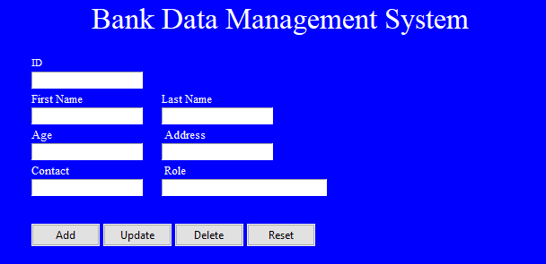

Figure 1 Interface

# Features

There are variety of features that covers this program such as

1. Adding feature
2. Updating feature
3. Deleting data feature
4. Reset the interface

These feature helps in adding the information into the database as well as updating it and also deleting it from the MySQL database.

# Adding Data

The add button is used to add the data that has been entered into the database. As show in the below diagram data can be easily added to the table which is then stored in the database.

Figure 2 Adding the data

# Updating Data

This is another feature of the program in which if there is any kind of changes in the real world it can be updated here in the table. This features comes in real handy when aspects like phone number or addresses changes in it.

Figure 3 Updating the database

# Deleting Data

The delete feature deletes the data in the table. This feature also has a pop up feature by which it can be known that the data is deleted permanently in the data. In the future work the it can be upgraded to ask a permission if the data should be deleted or not.

Figure 4 Deleting the data

# Reset

The reset button clears the interface so that new data can be inserted in the table. The reset feature basically refreshes all the input that has been left from adding or updating previous data.

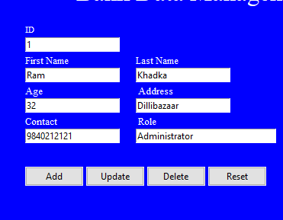

Figure 5 before

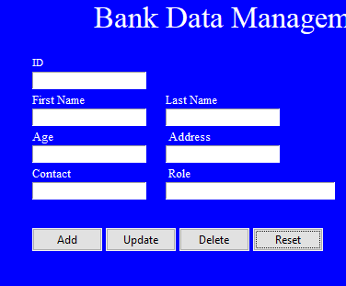

Figure 6 Resetting the interface

# Unit testing

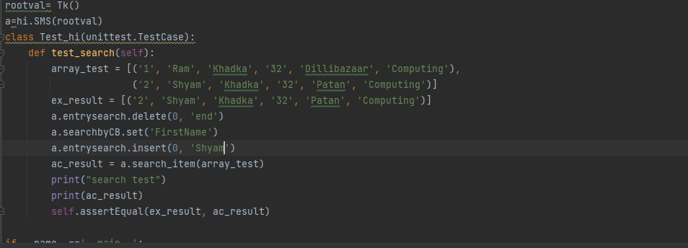

Figure 7 unit testing

# Conclusion

To summarize, a user-friendly Bank data management system was built with many basic features such as adding, updating, and removing information in a database in a controlled manner in a user application. Different program capabilities were also covered, and unit testing for evaluating the validity of the algorithm was supplied, which proves the validity of the algorithm to be valid, as well as a proper description of how to use the program.

# Appendix

